F51369
Gerber 2pk Zip Front Sleep ‘n Play

(NOTE: Photos are intended to show folding and packaging METHOD only. Aesthetic details of packaging components, garment details and UPC details may vary.)

STEP 1
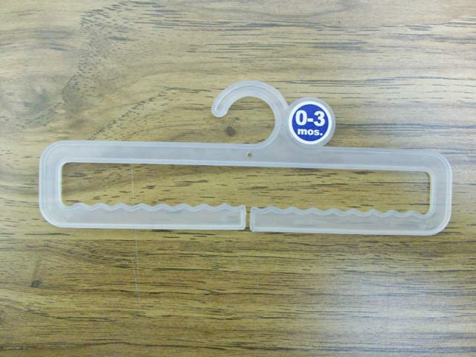
Place size sticker on circle on hanger. Correct hanger must have size circle.

STEP 2
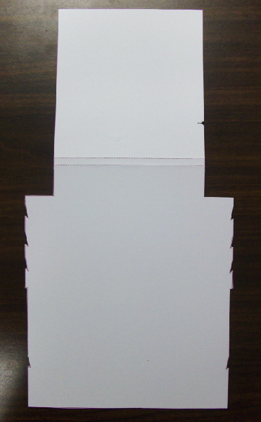
Obtain header card.
STEP 3
Align top of binding to the notch in the header card.
Place 1st garment on header card approximately 4.5” from the top of the header card unfolded. Align top of binging with notch in the header card.

STEP 4
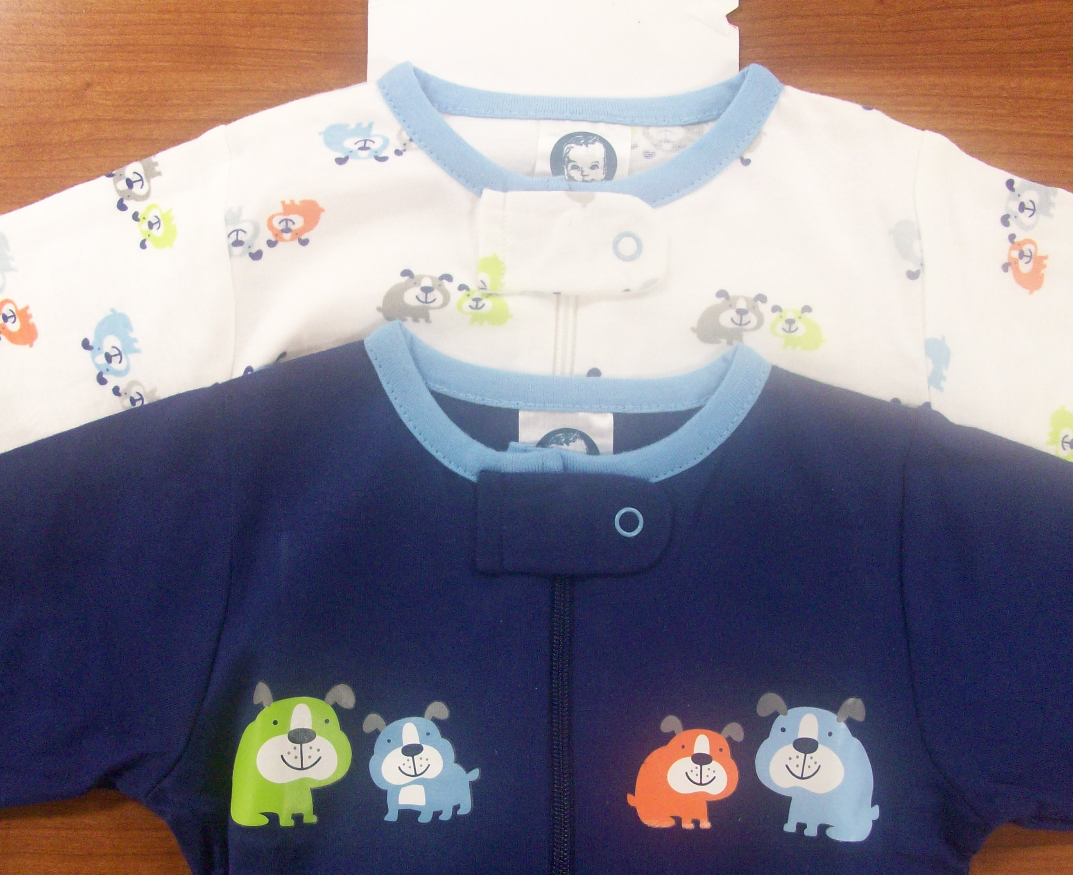
3”
Garments spacing must allow for heat transfer art to be completely visible above bottom edge of fold.

Place 2nd garment on top of 1st garment. Garments should be spaced approximately 3” apart.

STEP 5
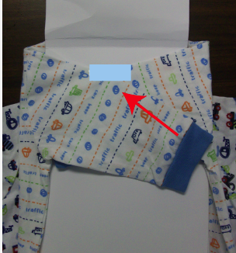
Turn garments over to back. Fold in sleeves and tape as shown.
(Tape required)
Any tape touching fabric must be 3M textile adhesive tape.

STEP 6
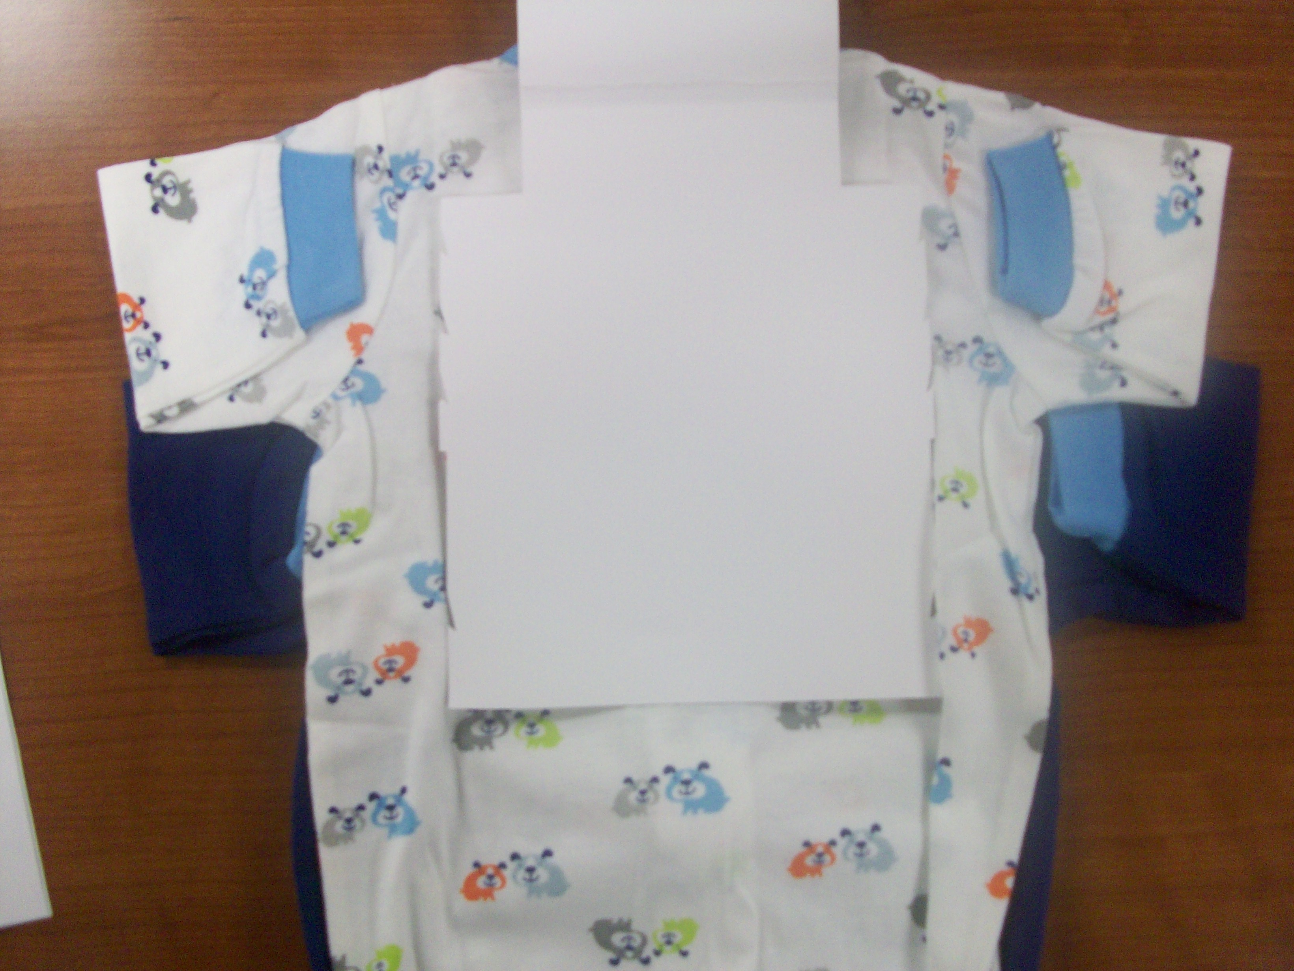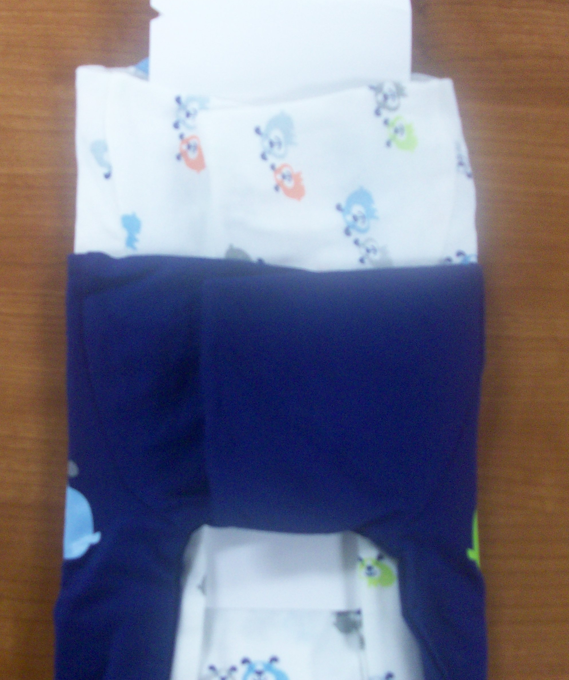
Fold sleeves of garments in toward header card and then fold them in over the header card. Tape the sleeves as shown, if needed.
Size NB will only require one fold, but sleeves of larger sizes will need to be folded over several times.

STEP 7
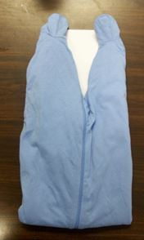
Fold legs up toward top of header card and tight to the bottom of the chipboard.

STEP 8
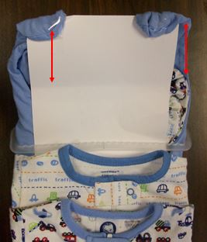
Flip over and tape feet to chipboard, as indicated by the red arrow above.
STEP 9
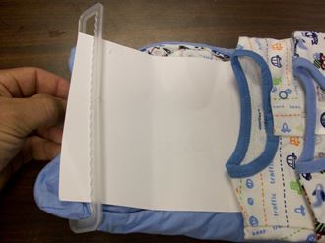
Slide hanger over header card and down to the fold in the chipboard.

STEP 10
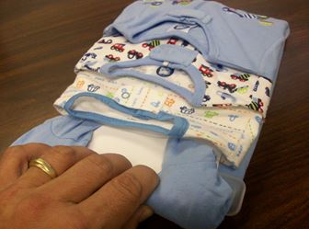
Tuck the chipboard with the taped feet behind the neckline of the garments.

STEP 11
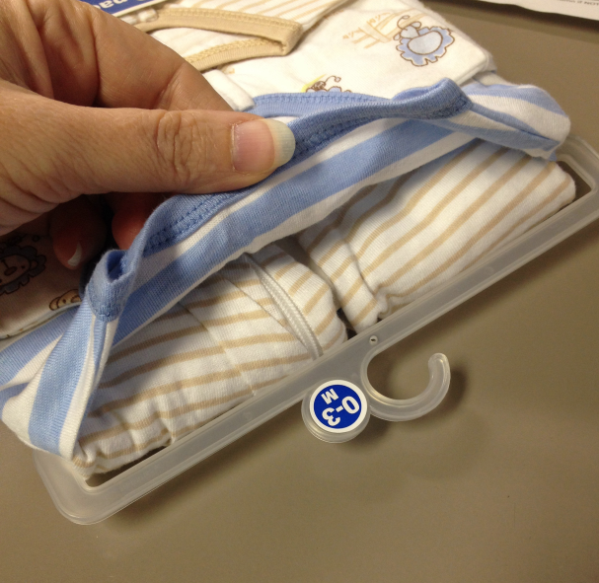
Place a strip of double-sided tape behind the neck of the top garment. Press garment down onto tape to secure it in place.

STEP 12
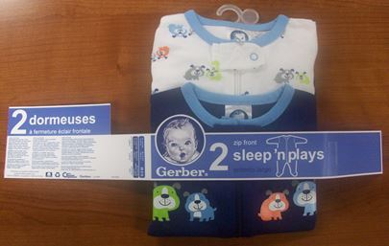
Place wrapband across front of garments, approximately 3 inches up from the bottom of the package. (The words on front of wrapband should NOT wrap around side of package, and the size chart should not be seen from the front.)

STEP 13
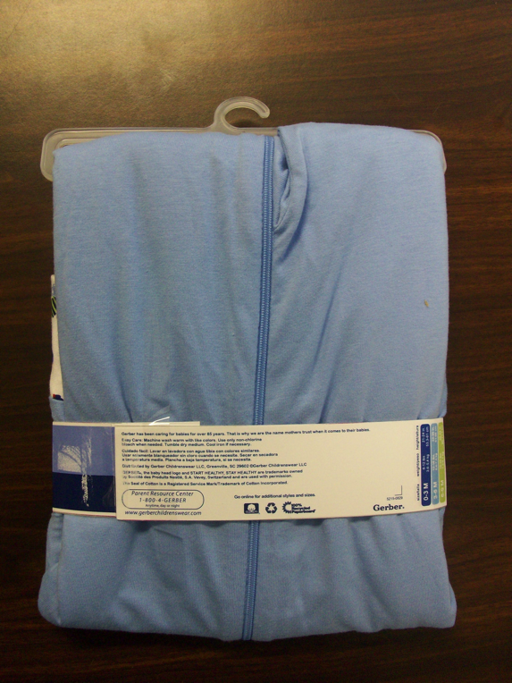
Turn garments over to back. Wrap wrapband around garments Tightly.

STEP 14
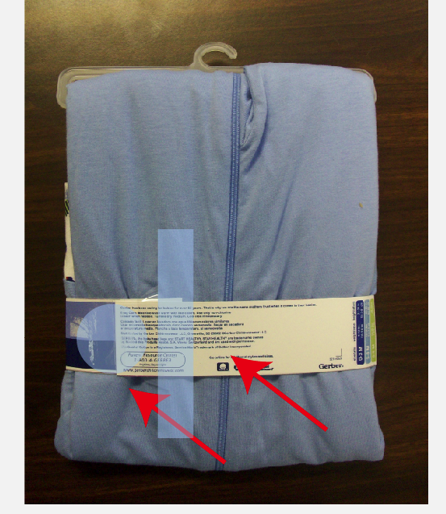
Place one clear round sticker (1.5” in diameter) over the closure to secure wrapband. Use approximately 4” piece of 3M textile adhesive tape to secure the wrapband to the garments.

STEP 15

8.5”
Wrapband Distance from bottom
3”
3”
Pkg length
(not incl. hook)
Garment spacing
Finished package should look like pictures above.
Garments should be in the order shown on the detail sheet.
Wrapband should be approximately 3” above bottom of garment.
Garments must be tightly and securely packaged.
NOTE: It is very important that the wrapband is TIGHT and securely adhered, in order to hold the garments tightly.



